**Final Year Project Proposal**

**Student Name:** Vincent Cheung

**Supervisor Name:** Paul Dunne

**Project Name:** Working Title

**Project Description**

The proposed project for the student is a game made in the Unity Game Engine, the game will be a 3D “stealth game” with elements focusing on hiding and avoiding detection. The student will have to create stages that a player will have to navigate through and complete objectives to complete the stages, this will use the Unity Game Engine. As well as that the student will be required to create and design their own characters for the game such as the player’s character as well as the enemies in the game or any other extra characters. The student will avoid making the game as linear as possible and there hopefully be multiple ways for a player to complete the stage.

The project will be programmed using C# which is the main language used in the games created by the Unity Game Engine.

**Technology Used**

The main component of the project is the Unity Game Engine, the creators of the engine are “Unity Technologies”. They describe the Unity Game engine as:

“A flexible and high-performance end-to-end development platform used to create rich interactive 2D, 3D, VR and AR experiences. Unity's powerful graphics engine and full-featured editor serve as the foundation to develop beautiful games or apps and easily bring them to multiple platforms: mobile devices, home entertainment systems, personal computers, and embedded systems.

Unity also offers solutions and services for creating games, boosting productivity, and connecting with audiences including the Unity Asset Store, Unity Cloud Build, Unity Analytics, Unity Ads, Unity Everyplay and Unity Certification.”

Another technology used in the project is the personal computer, the personal computer will be required to create and design the final year project that the student will create using the Unity Engine

**Architecture Diagram**

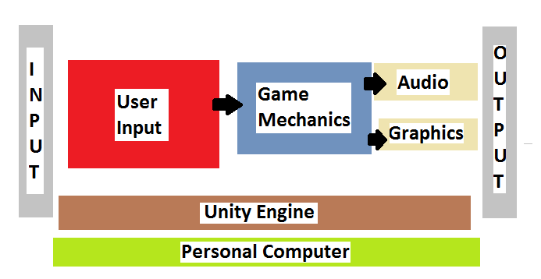

**Features of Project**

The main features of the projects will be:

* 3D game using the Unity Engine
* Stealth focused game that will be keyboard controlled
* Characters and stages created and designed by the student

**Possible Extra features of Project**

* Another form of controlling the character in the game
* Quests or extra objectives
* If stages, multiple ways to complete stages
* Database to keep a high score system for the game